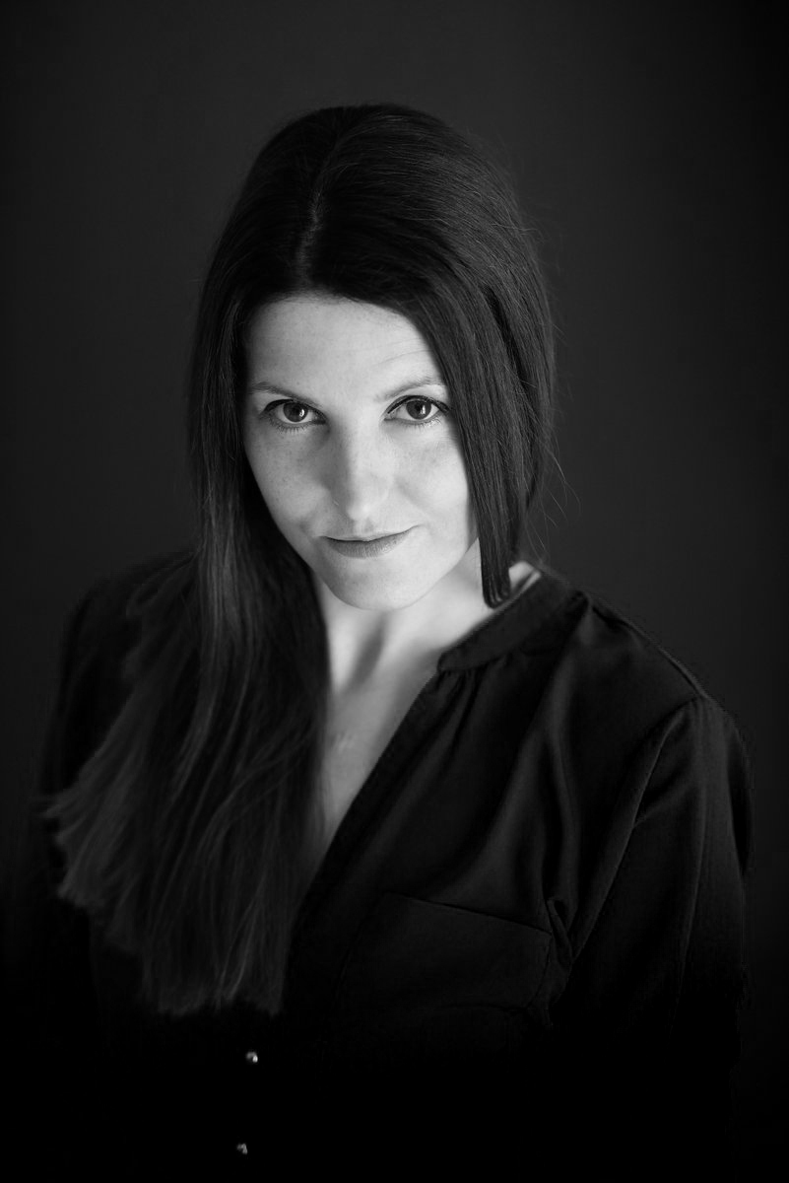
AISLING HOLIAN

Location: Nationwide Nationality: Irish
Height: 5'6 Hair Color: Brown
Weight: 9 stone Hair Length: Long
Playing Age: 27-37 Eye Colour: Brown

Showreel: http://vimeo.com/104051816
‘The Rasherman’ Trailer: http://vimeo.com/103994527

QUALIFICATIONS & TRAINING
YEAR  2014  2013  2013  2013  2013  2013  2010  2009  2009  2009-2008  2000-1997  1997-1991  1991-1986 | SCHOOL / ACADEMY  Screen Training Ireland  Core Theatre College  Core Theatre College  GVS Galway Voice Studio  Core Theatre College  Galway Actors Workshop  Ros & John Hubbard Casting  Gillian Reylon Casting  Ali Coffee Workshop  The National Film School IADT  Carlow I.T.  Gateswide Theatre  The Leinster School of Music | COURSE  Aud.Seminar-Maureen Hughes  Acting & Drama Studies  Anton Chekhov Workshop  Musical Theatre Singing Lessons  Voice - Chekhov Technique  Acting Summer Course  Acting & Audition Workshop  Acting & Audition Workshop  Acting & Audition Workshop  BA(Hons) Art Director & Design  Degree Product Design  Drama & Theatre Experience  Speech & Drama | LOCATION  Galway  Galway  Galway  Galway  Galway  Galway  London  Dublin  Dublin  Dun Laoghaire  Carlow  Galway  Galway

CREDITS
YEAR | TYPE | ROLE | PRODUCTION | DIRECTOR | COMPANY
2015 | Theatre | Lead | A Room With No View | Adrian Lavelle | A Wolf Meeta World Productions
2015 | Theatre | Lead-Melanie | 2.18 Finchley | Frankie Moran | Long Haired Freaky People  Productions
2015 | Short Film | Lead-Jeanne | Don’t follow the shadow | Miguel Angel Vinas | IADT
2015 –  2014 | Theatre | Principal -Rosie Pedals | Murder at Fawlty  Towers | Bruce Henry | Murder on the Menu Ireland
2014 | Theatre | Lead -Miranda Gates | Godhead | Adrian Lavelle | A Wolf Meets World Production
2014 | Theatre | Lead -Miss Gates | A Delicate Psyche | John O’Connor &  Adrian Lavelle | A DB Production
2014 | Commercial | Leslie Liplok | Hen Party &  Heartbreak | Bruce Henry | Murder on the menu Ireland
2014 | Corporate | Nurse | Training Video | J.St.John | Aerogen
2014 | Short Film | Principal -Pea Peaches | The Rasherman | Rory O’Shea | Petal Productions
2014 | Commercial | Friend | Littlewoods Ireland | Brian O’Malley | Red Rage Films
2014 | Short Film | Diane | Mystic | Ray Heaney | GMIT
2013 | Television | Journalist | Fainne LastaTeo | Darach Mac Con Iomaire | Corp + Anam a do
2012 | Short Film | Dr.Clarke | Memoria | Gavin McNulty | Zero Productions
2012 | Theatre | Noreen | The Bug | Owen Ward | Larking About Theatre Co.
2012 | Documentary | Mrs Agnas Mallin | 1916 Rising. The Forgotten Seven. (Seachtar Dearmadta) Part 1. Michael Mallin | Pierce Boyce | Abu Media
2011 | Educational | Mrs Edwards | Alcoholics Anonymous  (Educational Video)‘The Road Back’ | Moira Sweeney | Spirit Level Productions
2011 | Commercial | Lead | GAF TV | Howard Linnane | Galway Arts Festival
2011 | Film | Architect | Honeymoon for one | Kevin Connor | Larry Levinson Productions
2011 | Television | Karen | Rasai na Gaillimhe 2 | Robert Quinn | Rnag Gr2 Teoranta
2009 | Television | Queen Cathrine Parr’s  Lady in Waiting | The Tudors #4  Ep 6 – Ep 10 | Ciaran Donnelly | SW Productions
2009 | Television | Marie | Inspector George Gently #2 Ep2 | Ciaran Donnelly | Company Pictures  For BBC ONE
2009 | Film | Court Stenographer | Sensation | Tom Hall | Mac Daddy Film Productions
2008 | Television  Game Show | Skype Panel | Colm & Jim-Jim’s  Home Run | Philip Kampf | Vision Independent Productions

SKILLS
Singing (Rock/Contempary), Irish Dancing (basic), Ceili Dancing(basic),
Weapons handling training (Former member F.C.A.) First Aid Training (Former member Order of Malta), Basketball Player (Former defender Galway Ladies Team), Volleyball Player, Swimming, Horse Riding, Ice Skating, Rollerblading, Fire poi, Full Driving License.

ACCENTS
Irish, British (Standard), American (Southern), European (Spanish/Italian/French)

LANGUAGE French (basic), Spanish (basic), Gaelic (basic)

ADDITIONAL INFORMATION
I have featured in a number of productions and have been a stand-in for Actresses
such as Paz Vega, Kelly Reilly, Charlene McKenna and Elaine Cassidy.
2009, Film, The Guard, Background Artist, Reprisal Films/Element Pictures, Director Larry Smith
2008, Film, Little White Lie, Background Artist, Cabra TV Ltd, Director Nicholas Renton
2008, Film, Triage, Background Artist, Darkroom Productions Ltd, Director Danis Tanovic
2008, Film, Kisses, Background Artist, Fastnet Films, Director Lance Daly
2008, Commercial, National Lotto Monday Millions, Extra, RTE
2008, Television, RAW, Background Artist, FB Productions Ltd, Director Kieron J. Walsh,
2008-2006, Television, The Clinic, Background Artist, Parallel Films, Director Liam Cunningham,
2008, Documentary, High Society, Background Artist, Big Mountain Productions, Director Jane Kelly
2008-2005, Television, Fair City, Background Artist, RTE
2008-2005, Television, Ros Na Run, Background Artist, TG4

